**Problem 3**

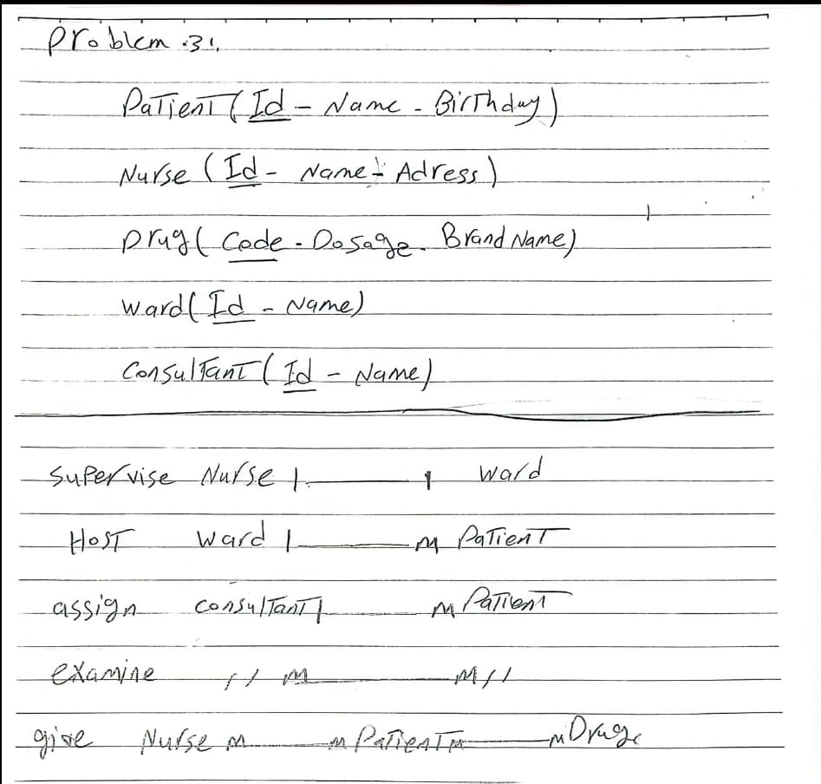

M

M

M

M

M

M

M

1

1

1

1